Universität Duisburg-Essen

Summer Semester 2026
Advance R for Econometrician
Table of Contents
1. Introduction 3
2. Development of Application 3
2.1 User Interface 4
2.2 Server 6
2.3 Integrating LLM 7
3. Diagnostic 7
3.1 Linear Regression Model 7
3.2 Logistic Regression Model 8
3.3 Time Series Model 8
References 9

Introduction
Linear regression remains a foundational statistical method for examining relationships between continuous outcomes and predictor variables. However, ensuring that core underlying assumptions—namely linearity, homoscedasticity, and normality—are met is essential for obtaining unbiased parameter estimates and valid hypothesis tests. However, misconceptions about these assumptions, especially among non-statisticians, still exist and often hinder proper diagnostics. To address this challenge, we developed the Diagnostic App, an interactive Shiny web application designed in R to assist researchers in assessing normality, homoscedasticity, and linearity assumptions, and in handling violations effectively. The application enables researchers to evaluate regression assumptions and address potential violations without requiring prior programming experience in R. Additionally, the app is reactive, meaning it responds instantly to the user’s input and updates plots and results in real-time

In addition to classical linear regression, the application extends diagnostic functionality to logistic regression and time series models. The application is implemented using a modular ecosystem of R packages, including shinydashboard for layout structure, ggplot2 for custom data visualization, and gt for publication-ready tables. Furthermore, an integrated Large Language Model (LLM) automatically generates natural language interpretations of model coefficients, fit metrics, and diagnostic evaluations

Development of Application
While a standard Shiny framework provides basic web application functionality, we opted for the shinydashboardpackage to build our application due to its structured layout, visual clarity, and modern user interface designed specifically for analytical dashboards.
In R Shiny, an application is built on two core components:
- User Interface (ui): Defined using the dashboardPage() function, the UI controls the visual presentation and layout. To maintain clean, readable code, we assign this layout object to ui. The layout consists of three essential structural components:
  - dashboardHeader(): Displays the title and top-level menu bar.
  - dashboardSidebar(): Contains navigation links and controls to switch between different tabItem() views.
  - dashboardBody(): Serves as the primary content area holding visual outputs, data tables, and input widgets.
- Server (server): A custom R function that handles the application's backend logic, managing data processing and reactivity to update visual outputs dynamically based on user inputs.
Finally, the shinyApp(ui, server) function binds the interface and backend logic together to render the interactive dashboard.

2.1 User Interface
Our App interface has one side bar with three menu items: Setup, Diagnostics and Tranformation

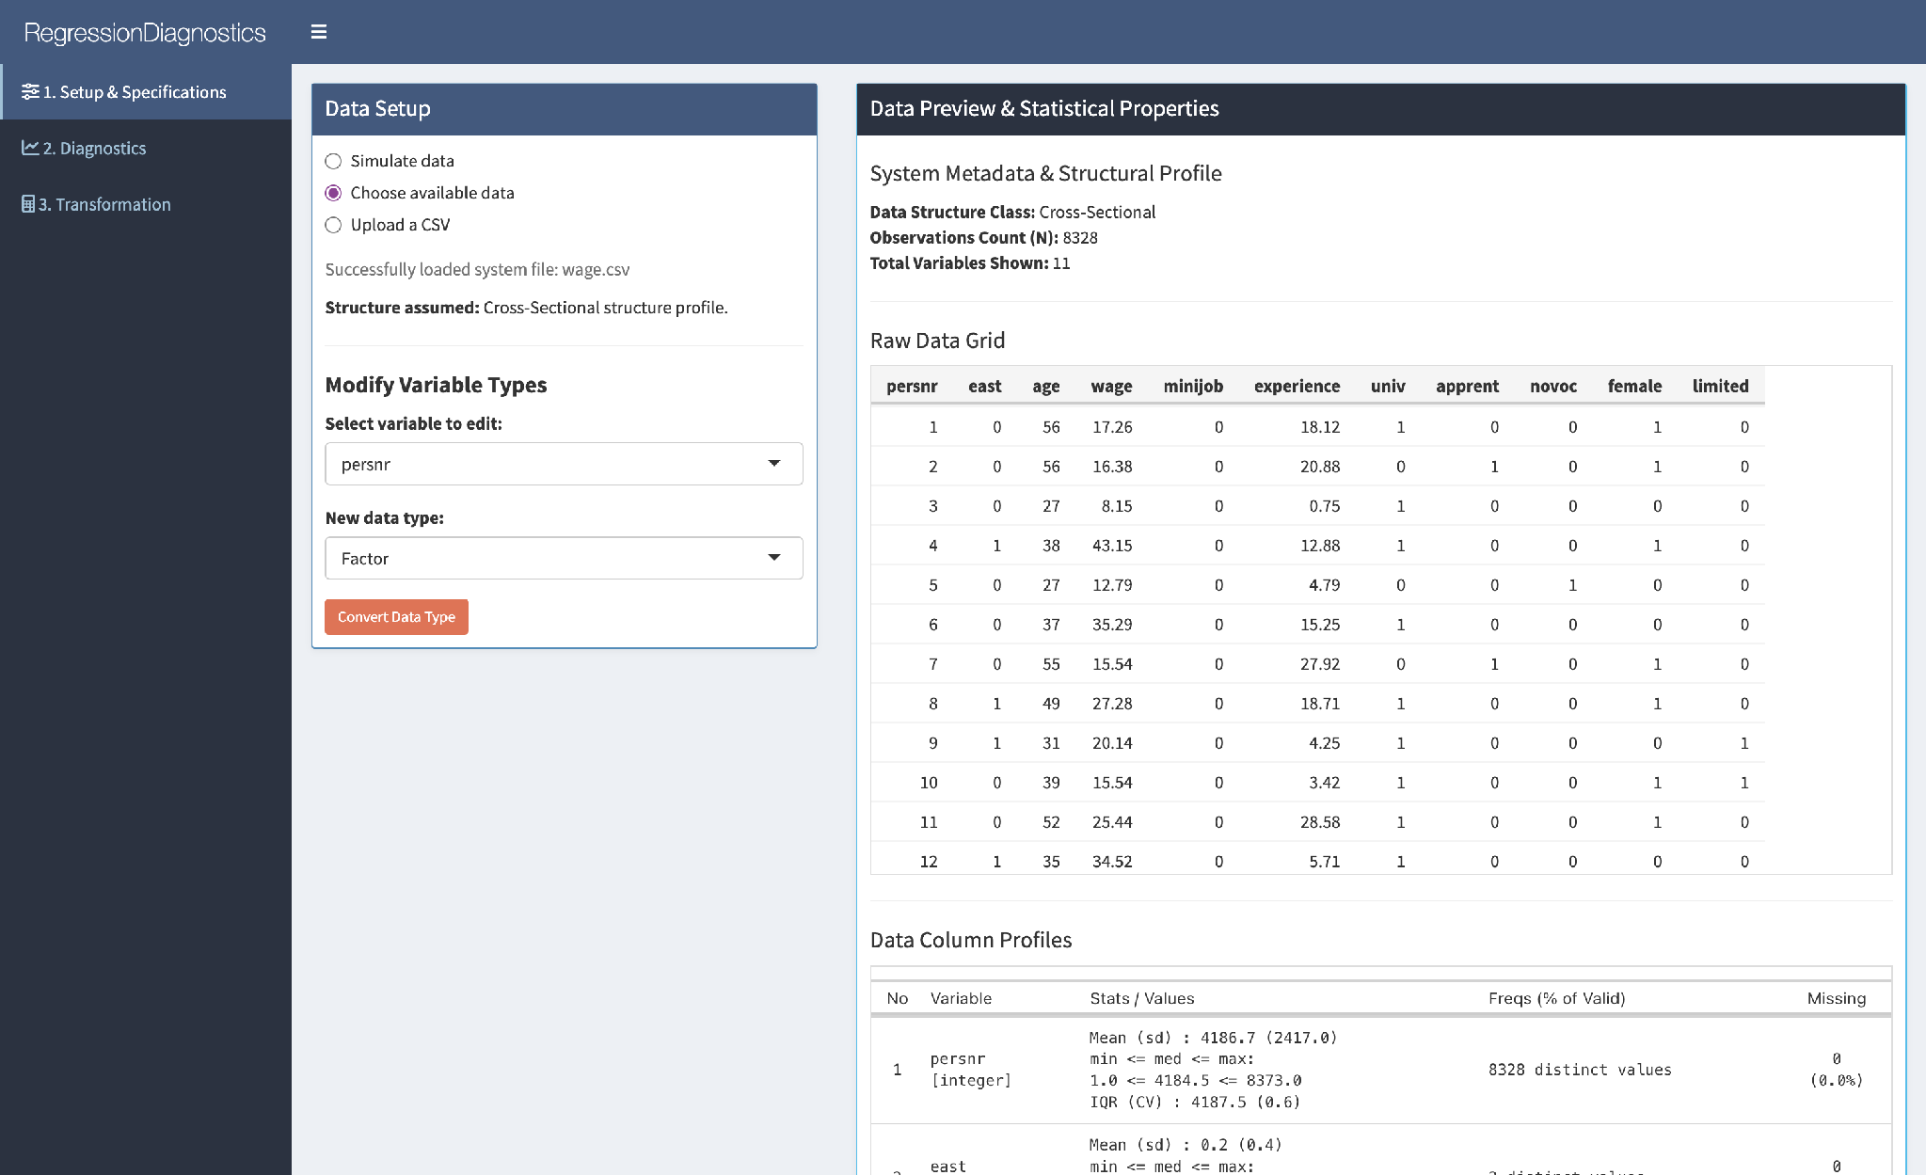
Figure 1: App Interface

Step 1: Data Setup
Here User can Select an example dataset, Simulate the data or load data file. To change a data type, select a variable to edit, choose the New data type and apply changes using the Convert data type button. The Data Preview tab shows a preview of the data (observations, number of column, number of rows), descriptive statistic (data type, missing value), distribution of variables also correlation table.

Step 2: Diagnostic

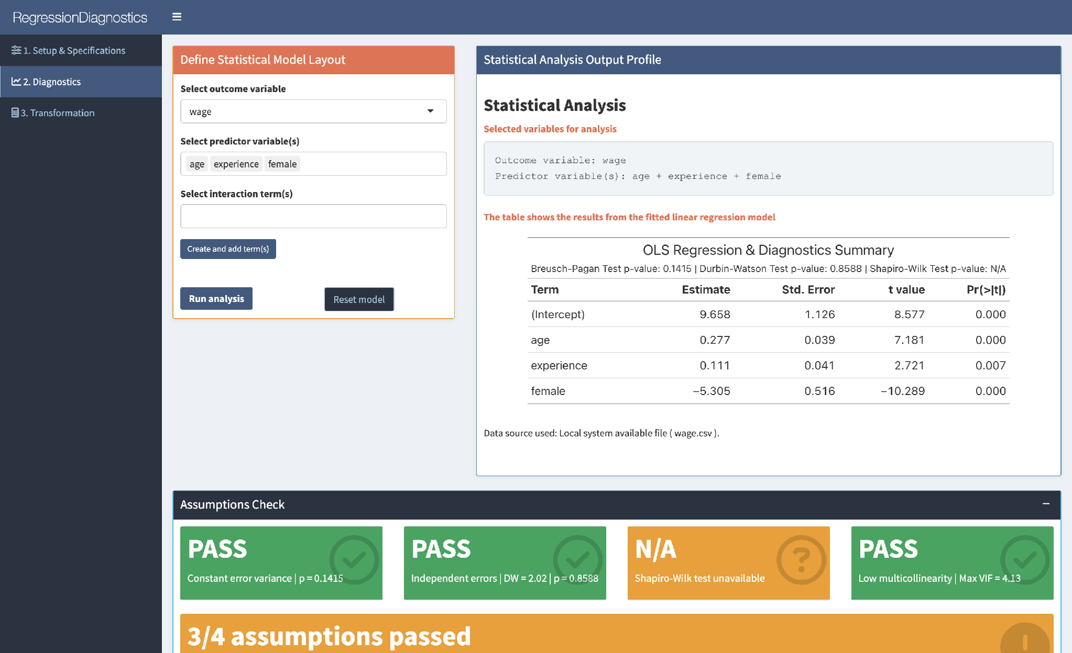

The Define Model sidebar tab allows users to select the outcome variable and one or more predictor variables. If the model contains interaction terms, one can create and add them to the model by marking the checkbox. The model is then run by clicking the Run Analysis button and viewing the fitted regression model results on the right

Below the Model Summary, KPI value boxes provide a quick overview of the model performance. In addition, four diagnostic status boxes display the results of the Breusch–Pagan, Durbin–Watson, Shapiro–Wilk, and VIF diagnostics. An overall diagnostic status summarizes the results of these four checks, allowing users to quickly identify potential model problems. The diagnostic plots displayed underneath provide additional graphical assessments of the fitted regression model. The Residuals vs Fitted Values plot assesses the linearity assumption and helps identify non-linear patterns. The Q-Q plot and histogram of residuals provide graphical assessments of residual normality, while the Scale-Location plot is used to assess homoscedasticity.
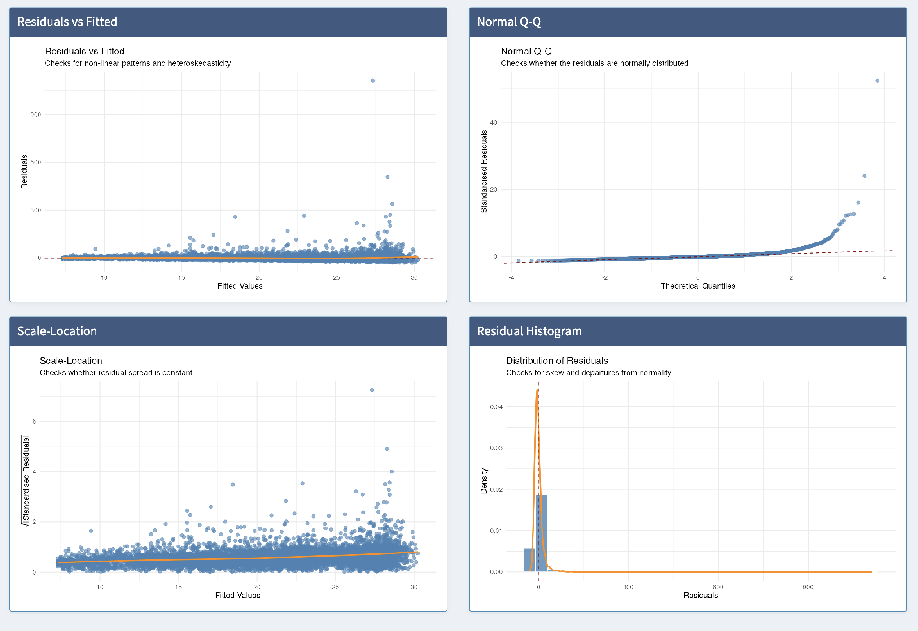

Step 3: Data transformation
After assessing the plots, the next step is to make any data transformations necessary. If there are no violations, leave this step. In this step you can select a variable to transform from the drop-down menu and choose a transformation type from the list. Type in the extension to the transformed variable before clicking Apply Changes. Data will automatically update with the transformed variable in the last column.

Below, we describe the transformation functions:
- Ln (natural log): takes the natural logarithm of the variable, which helps reduce skewness and makes data more normally distributed.
- Exp: calculates the exponential function of the variable, which helps reverse the natural logarithm transformation.
- Square: raises the variable to the power of 2, often used to capture quadratic relationships in data.
- Square root: takes the square root of the variable, helpful for stabilising variance and reducing skewness.
- Standardise: centres the variable around its mean and scales it to have a standard deviation of 1, ensuring all variables are on the same scale.
- Log return: Transform for time series data

After data transformation, return to Step 2 and rerun the analysis with the transformed variables.

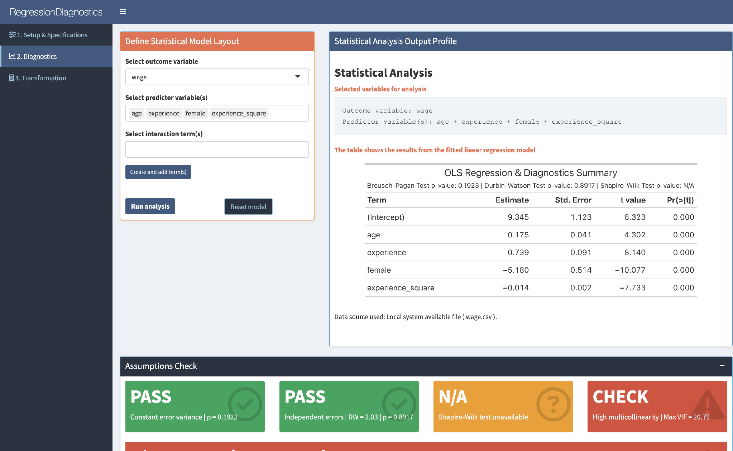

2.2 Server

renderUI, renderValuebox, rendergt

Regression Diagnostics Module
The regression diagnostics module provides a structured and user-friendly evaluation of linear regression models. The diagnostic results are collected and processed within the diag_Im S3 class and subsequently passed to the user interface. The module incorporates four diagnostic checks: the Breusch–Pagan test for heteroscedasticity, the Durbin–Watson test for residual autocorrelation, the Variance Inflation Factor (VIF) for multicollinearity, and the Shapiro–Wilk test for residual normality.
To facilitate the interpretation of these statistical outputs, the application uses a rule-based interpretation system. Each of the four diagnostic results is automatically evaluated according to predefined decision rules and translated into a PASS/CHECK status indicator. For the Breusch–Pagan and Shapiro–Wilk tests, the respective p-values are evaluated against the defined significance level. Multicollinearity is evaluated based on the maximum VIF value, while the Durbin–Watson diagnostic is evaluated according to its corresponding result.
The results are presented in the user interface through reactive diagnostic status boxes, which display the outcome of each diagnostic together with the relevant statistic or p-value. An additional overall diagnostic status combines the four individual results. If all four diagnostic checks pass, the overall status is displayed in green; if three out of four pass, it is displayed in blue; and if two or fewer pass, it is displayed in red. The diagnostic output is updated reactively whenever the fitted model changes.

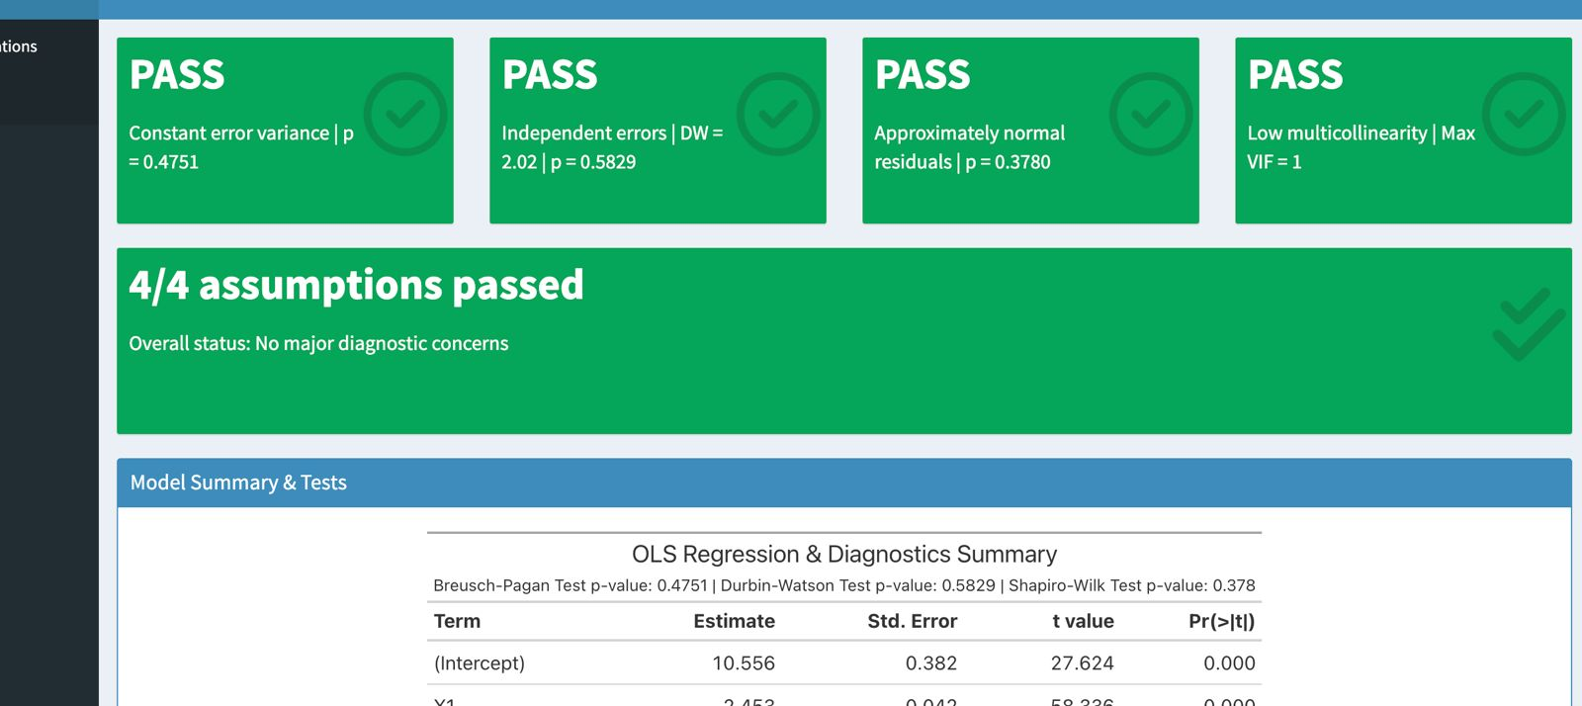

2.3 Integrating LLM

Diagnostic

3.1 Linear Regression Model
The four foundational assumptions of Ordinary Least Squares (OLS) linear regression are:
- Linear in parameters: The relationship between the independent and dependent variables is linear.
- Random Sampling: all observations are identically and independently distributed
- No perfect Multicollinearity: There is no perfect linear relationship between the independent variables.
- Zero Conditional Mean : Unobserved variables (contained in ) must be mean independent with any explanatory variables
Under assumption 1 to 4 the OLS is unbisased .
Assumption 5: Homoskedascity
Heteroscedasticity, although not directly biasing the model, can still affect the accuracy of standard errors, which impacts the validity of inference so under assumption 5 the error u has the same variance given any values of the expalnatory variables.

All these assumptions and potential problems can be checked by producing some diagnostic plots visualizing the residual errors.

You should check whether or not these assumptions hold. Potential problems include:Non-linearity of the outcome - predictor relationships, Heteroscedasticity: Non-constant variance of error terms, Presence of influential values in the data that can be:
  - Outliers: extreme values in the outcome (y) variable
  - High-leverage points: extreme values in the predictors (x) variable

The diagnostic plots show residuals in four different ways:
- Residuals vs Fitted. Used to check the linear relationship assumptions. A horizontal line, without distinct patterns is an indication for a linear relationship, what is good.
- Normal Q-Q. Used to examine whether the residuals are normally distributed. It’s good if residuals points follow the straight dashed line.
- Scale-Location (or Spread-Location). Used to check the homogeneity of variance of the residuals (homoscedasticity). Horizontal line with equally spread points is a good indication of homoscedasticity. This is not the case in our example, where we have a heteroscedasticity problem.
- Residuals vs Leverage. Used to identify influential cases, that is extreme values that might influence the regression results when included or excluded from the analysis. An influential value is a value, which inclusion or exclusion can alter the results of the regression analysis. Such a value is associated with a large residual.

Not all outliers (or extreme data points) are influential in linear regression analysis.
Statisticians have developed a metric called Cook’s distance to determine the influence of a value. This metric defines influence as a combination of leverage and residual size.

Statistical Diagnostic Tests
In addition to the graphical diagnostic tools, the application provides four statistical diagnostic checks for the fitted linear regression model.
The Breusch–Pagan test is used to detect heteroscedasticity in the regression residuals. The null hypothesis assumes constant error variance (homoscedasticity). A p-value below the significance level of 0.05 therefore indicates evidence of heteroscedasticity, while a p-value greater than or equal to 0.05 does not provide sufficient evidence to reject homoscedasticity.
The Durbin–Watson test is used to detect autocorrelation in the regression residuals. A Durbin–Watson statistic close to 2 indicates little evidence of first-order autocorrelation, while values substantially below or above 2 may indicate positive or negative autocorrelation, respectively.
The Shapiro–Wilk test provides a formal statistical assessment of residual normality and complements the graphical assessment provided by the Q-Q plot and residual histogram. The null hypothesis assumes that the residuals are normally distributed. A p-value below 0.05 therefore provides evidence against the normality assumption.
The Variance Inflation Factor (VIF) is used to assess multicollinearity among the explanatory variables. Higher VIF values indicate stronger linear relationships between a predictor and the remaining predictors. The application reports the maximum VIF and uses a predefined threshold to identify potentially problematic multicollinearity.
The results of these four checks are subsequently translated into the PASS/CHECK indicators described in Section 2.2, providing both statistical results and an accessible summary of the diagnostic evaluation.

3.2 Logistic Regression Model
Logistic regression is used when predicting binary outcomes. The assumptions of normality and homoscedasticity do not apply to logistic regression, but others do: Linearity, Independence, No multicollinearity, No outlier effect.

3.3 Time Series Model
Time series analysis includes methods for analyzing time series data to extract meaningful statistics from the data. In the context of finance and econometrics, the primary goal of time series analysis is to predict future values based on previously observed data points, which we refer to as forecasting. In our app, we make some model diagnostic and validation techniques to evaluate time series model.
In general, a time series is a sequence of observations taken at regular time intervals. Depending on the frequency of the observations, these time intervals may be annual, quarterly, monthly, weekly, daily, or even intraday. Time series analysis requires some basic concepts such as autocorrelation process, and the fundamental property for time series models, stationarity.

Autocorrelation is the correlation of a single time series with its lagged values. It can also be called lagged correlation because it measures the relationship between the current value of a variable and its past values. Again, the resulting output can range from 1 to -1, as with traditional correlation. Financial analysts use the idea of autocorrelation to examine how much the past price of a security affects its future price. We will plot the autocorrelation in our app.

Stationarity means that the statistical properties of a process do not change over time. Stationarity is a common assumption for many time series models. If a time series is not stationary, then it becomes difficult to model. Modeling involves estimating a set of parameters that are required for forecasting. For example, if you calculate the mean of a non-stationary time series, it will not give you any useful informaton for any forecasting of the future. Time series with trends, or with seasonality are not stationary because the trend and seasonality will affect the value of the time series at different times. One way to make non-stationary time series stationary is computing the differences between consecutive observations. Sometimes you need to apply higher order differences. Transformations such as logarithms can help to stabilise the variance of a time series. Differencing can help stabilise the mean of a time series by removing changes in the level of a time series, and therefore eliminating (or reducing) trend and seasonality. We test for stationary by applying Augmented Dickey Fuller Test.

References

Datacamp. „Components of Shiny Dashboard“. o. J. https://campus.datacamp.com/pdf/web/viewer.html?file=https://projector-video-pdf-converter.datacamp.com/31088/chapter2.pdf#page=7.
Park, Kun Il. Fundamentals of Probability and Stochastic Processes with Applications to Communications. 1st ed. 2018 edition. Springer International Publishing AG, 2017.
Struck, Jason. „Regression Diagnostics with R“. 2024. https://sscc.wisc.edu/sscc/pubs/RegDiag-R/index.html.
Wooldridge, Jeffrey M. Introductory Econometrics : A Modern Approach. [Hauptband] / Jeffrey M. Wooldridge, Michigan State University. In Introductory Econometrics a Modern Approach [Hauptband] / Jeffrey M. Wooldridge, Michigan State University, Seventh edition. 2020.

Datacamp(2026).
Wooldridge(2020):40-45
Struck (2024).
Park (2017)

